BULLETIN OF THE POLISH ACADEMY OF SCIENCES
TECHNICAL SCIENCES
DOI:10.24425/bpasts.yyyy.xxxxxx
Preparation of Papers for BPASTS
Author(s) Name Last Name^{1, 2} (Remove for evaluation process)
¹ Affiliation (Remove for evaluation process)
² Affiliation (Remove for evaluation process)
Abstract.. This electronic document is a “live” template and already defines the components of your paper [title, text, heads, etc.] in its style sheet. The abstract must be written as one paragraph. An informative and short abstract (10–15 lines) should be given at the beginning of the paper. Do not use symbols, special characters, or math in paper title or abstract. The abstract should not contain displayed mathematical equations or tabular material. (Abstract)
Key words: component; formatting; style; styling; insert (Key words)

INTRODUCTION
This MS Word template provides authors with most of the formatting specifications needed for preparing electronic versions of their papers. All standard paper components have been specified for three reasons: (1) ease of use when formatting individual papers, (2) automatic compliance to electronic requirements that facilitate the concurrent or later production of electronic products, and (3) conformity of style throughout the journal issue. Margins, column widths, line spacing, and type styles are built-in; examples of the type styles are provided throughout this document and are identified in italic type, within parentheses, following the example. Some components, such as multi-leveled equations, graphics, and tables are not prescribed, although the various table text styles are provided. The formatter needs creation of these components, incorporating the applicable criteria that follow.

EASE OF USE

Selecting a template
First, confirm that you have the correct template for your paper size. This template has been tailored for output on the A4 paper size.

Maintaining the integrity of the specifications.

The template is used to format your paper and style the The template is used to format your paper and style the text. All margins, column widths, line spaces, and text fonts are prescribed; please do not alter them. Please do not revise any of the current designations.

PREPARE YOUR PAPER BEFORE STYLING
Before you begin to format your paper, first write and save the content as a separate text file. Keep your text and graphic files separate until after the text has been formatted and styled. Do not use hard tabs, and limit use of hard returns to only one return at the end of a paragraph. Do not add any kind of pagination anywhere in the paper. Do not number text heads-the template will do that for you.
*e-mail: smith@university.edu.pl (Remove for evaluation process)
Finally, complete content and organizational editing before formatting. Please take note of the following items when proofreading spelling and grammar:

Abbreviations and acronyms.
Define abbreviations and acronyms the first time they are used in the text, even after they have been defined in the abstract. Abbreviations such as IEEE, SI, MKS, CGS, sc, dc, and rms do not have to be defined. Do not use abbreviations in the title or heads unless they are unavoidable.

Units.
Use either SI (MKS) or CGS as primary units. (SI units are encouraged.) English units may be used as secondary units (in parentheses). An exception would be the use of English units as identifiers in trade, such as “3.5-inch disk drive.”
Avoid combining SI and CGS units, such as current in amperes and magnetic field in oersteds. This often leads to confusion because equations do not balance dimensionally. If you must use mixed units, clearly state the units for each quantity that you use in an equation.
Do not mix complete spellings and abbreviations of units: “Wb/m2” or “webers per square meter,” not “webers/m2.” Spell units when they appear in text: “...a few henries,” not “...a few H.”
Use a zero before decimal points: “0.25,” not “.25.” Use “cm3,” not “cc.”

Equations.
The equations are an exception to the prescribed specifications of this template. You will need to determine whether or not your equation should be typed using either the Times New Roman, Cambria Math or the Symbol font (please no other font).
Number equations consecutively. Equation numbers, within parentheses, are to position flush right, as in (1), using a right tab stop. To make your equations more compact, you may use the solidus ( / ), the exp function, or appropriate exponents. Italicize Roman symbols for quantities and variables, but not Greek symbols. Use a long dash rather than a hyphen for a minus sign. Punctuate equations with commas or periods when they are part of a sentence, as in
${\left(x+a\right)}^{n}=\sum_{k=0}^{n}{\left({n \atop k}\right)x^{k}a^{n-k}}$ 
Note, that the equation is centered using a center tab stop. Be sure that the symbols in your equation have been defined before or immediately following the equation. Italicize symbols (T might refer to temperature, but T is the unit tesla). In text refer to “Eq. (1)”, not “(1),” or “equation (1),” except at the beginning of a sentence: “Equation (1) is ...”

Some Common Mistakes.
• The subscript for the permeability of vacuum ε0, and other common scientific constants, is zero with subscript formatting, not a lowercase letter “o.”
• In American English, commas, semi-/colons, periods, question and exclamation marks are located within quotation marks only when a complete thought or name is cited, such as a title or full quotation. When quotation marks are used, instead of a bold or italic typeface, to highlight a word or phrase, punctuation should appear outside of the quotation marks. A parenthetical phrase or statement at the end of a sentence is punctuated outside of the closing parenthesis (like this). (A parenthetical sentence is punctuated within the parentheses.)
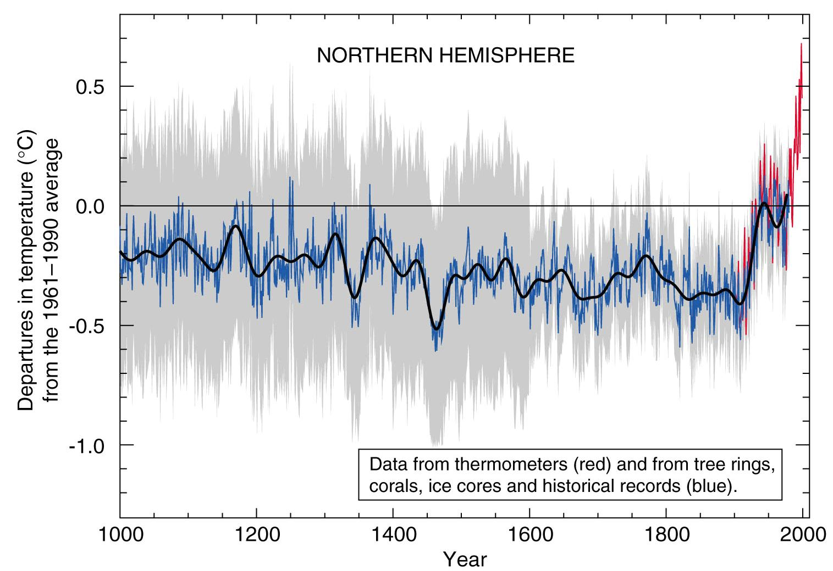
Fig.1. Famous Hockey stick graph

We suggest that you use a text box to insert a graphic (which is ideally a 300 dpi resolution TIFF or EPS file with all fonts embedded) because this method is somewhat more stable than directly inserting a picture.

- Be aware of the different meanings of the homophones “affect” and “effect,” “complement” and “compliment,” “discreet” and “discrete,” “principal” and “principle.”
- The prefix “non” is not a word; it should be joined to the word it modifies, usually without a hyphen.
- There is no period after the “et” in the Latin abbreviation “et al.”
- The abbreviation “i.e.” means “that is,” and the abbreviation “e.g.” means “for example.”

USING THE TEMPLATE
After the text edit has been completed, the paper is ready for the template. Duplicate the template file by using the Save As command, and use the naming convention prescribed by the journal for the name of your paper. In this newly created file, highlight all of the contents and import your prepared text file. You are now ready to style your paper; use the scroll down window on the left of the MS Word Formatting toolbar.

Authors and affiliations.
The template is designed so that author affiliations are not repeated each time for multiple authors of the same affiliation. Please keep your affiliations as succinct as possible (for example, do not differentiate among departments of the same organization). This template was designed for two affiliations.

Identify the headings.
Headings, or heads, are organizational devices that guide the reader through your paper. There are two types: component heads and text heads.
Component heads identify the different components of your paper and are not topically subordinate to each other. Examples include Acknowledgements and References. Use “figure caption” for your Figure captions, and “table head” for your table title. Run-in heads, such as “Abstract,” will require you to apply a style (in this case, bold) in addition to the style provided by the drop down menu to differentiate the head from the text.
Text heads organize the topics on a relational, hierarchical basis. If there are two or more sub-topics, the next level head (arabic numerals) should be used and, conversely, if there are not at least two sub-topics, then no subheads should be introduced. For the main level head style named “Heading 1” is prescribed.

Figures and tables.
Positioning Figures and Tables: Place figures and tables at the top and bottom of columns. Avoid placing them in the middle of columns. Large figures and tables may span across both columns. Figure captions should be placed below the figures; table heads should appear above the tables. All captions and table heads should be editable. Insert figures and tables after they are cited in the text. Use the abbreviation “Fig. 1,” however at the beginning of a sentence use “Figure 1”. Do not abbreviate “Table”.
Table 1. Results of simulation
header | Exp. 1 | Exp.2 | Exp.3
One | 0.001 | 0.002 | 0.003
Two | 15 | 30 | 45
Three | –0.1 | 0 | 0.1

Figure labels: Use 8 point Times New Roman for Figure labels. Use words rather than symbols or abbreviations when writing Figure axis labels to avoid confusing the reader. As an example, write the quantity “Magnetization,” or “Magnetization, M,” not just “M.” If including units in the label, present them within parentheses. Do not label axes only with units. In the example, write “Magnetization (A/m)”. Do not label axes with a ratio of quantities and units. For example, write “Temperature (K),” not “Temperature/K.”

CONCLUSIONS
Provided WORD document and Mendeley style are responsible for proper formatting of your paper. The authors are encouraged to take advantage of these possibilities and avoid manual modification of formatting.
APPENDIX
Appendixes, if needed, appear before the acknowledgment.
ACKNOWLEDGEMENTS
Avoid the stilted expression “one of us (R. B. G.) thanks ...”. Instead, try “R. B. G. thanks...”. Put sponsor acknow-ledgements unnumbered at the end of the text and before References.
REFERENCES
Since 1 January 2021 we apply the IEEE Citation Style.
It is suggested for authors to use specialized platform for selection and writing References for example Mendeley:
(https://www.mendeley.com/reference-management/
reference-manager), Zotero or other reference manager. It is strongly recommended to provide doi where possible [4]
Any citation style is set up to give the reader immediate information about sources cited in the text. In IEEE style citations, the references should be numbered and appear in the order they appear in the text. When referring to a reference in the text of the document, put the number of the reference in square brackets. Eg: [1].
The IEEE citation style has 3 main features:
- The author name is first name (or initial) and last name.
- The title of an article (or chapter, conference paper, patent etc.) is in quotation marks.
- The title of the journal or book is in italics.
These conventions allow the reader to distinguish between types of reference at a glance. The correct placement of periods, commas and other punctuation marks depends on the type of reference cited. Check the examples below. Follow the details exactly. E.g., put periods after author and book title, cite page numbers as pp., abbreviate all months to the first three letters (eg. Jun.)
Check the distinctions between print and electronic sources (especially for journals) carefully.

Examples
Book:
Author(s), Book title, Location: Publishing company, year, pp.
- M.P. Kazmierkowski and H. Tunia. Automatic Control of Converter-Fed Drives. Amsterdam, London, New York, Tokyo, Warsaw: Elsevier, 1994, pp. 37–68.
Book Chapters
Author(s). “Chapter title” in Book title, edition, volume. Editors name, Ed. Publishing location: Publishing company, year, pp.
- M.P. Kazmierkowski, “Control of Converter-Fed Induction Motor Drives,” in Industrial Electronics Handbook - Power Electronics and Motor Drives, 2nd ed., B. M. Wilamowski and J. D. Irvin, Eds. Boca Raton: CRC Taylor & Francis, 2011, pp. 21-1–21-39, doi: 10.1201/b10643-26.
Article in a Journal
Author(s). “Article title”. Journal title, vol., pp, date.
- D. Stando and M. P. Kazmierkowski, “Constant switching frequency predictive control scheme for three-level inverter-fed sensorless induction motor drive,” Bull. Polish Acad. Sci. Tech. Sci., vol. 68, no. 5, pp. 1057–1068, 2020, doi: 10.24425/bpasts.2020.134668.
Articles from Conference Proceedings (published)
Author(s). “Article title.” in Conference proceedings, year, pp.
- T. Kaczorek, “Extensions of the Cayley–Hamilton theorem to fractional descriptor linear systems,” in Proc. 21st Int. Conf. Methods Models Autom. Robot. (MMAR), 2016, pp. 838–843,
doi:10.1109/MMAR.2016.7575246.
Papers Presented at Conferences (unpublished)
Author(s). “Paper’s title,” Conference name, Location, year.
- B. Brandli and M. Dick. “Engineering names and concepts,” presented at the 2nd Int. Conf. Engineering Education, Frankfurt, Germany, 2009.
Standards/Patents
Author(s)/Inventor(s). “Name/Title,” Country where patent is registered. Patent number, date.
- E.E. Rebecca. “Alternating current fed power supply,” U.S. Patent 7 897 777, Nov. 3, 1987.
Books (on-line)
Author(s), “Title of chapter in the book,” in Title of Published Book, xth ed. Publishing location: Publishing company, year, pp. [Online]. Available: http://www.web.com [date accessed]
- P. B. Kurland and R. Lerner, Eds., The Founders’ Constitution. Chicago, IL, USA: Univ. of Chicago Press, 1987. [Online]. Available: http://press-pubs.uchicago.edu/founders/ [Accessed: 13. Dec. 2020]
Journal (on-line)
Author(s), “Name of paper,” Journal title, vol., pp, date, doi: xxx. [Online]. Available: site/path/file. [date accessed]
- A. Paul, “Electrical properties of flying machines,” Flying Machines. vol. 38, no. 1, pp. 778-998, Oct. 1987. [Online]. Available: www.flyingmachjourn/properties/fly.edu. [Accessed: 13 Dec. 2020].
World Wide Web
Author(s). “Page Title.” Website Title. [Online]. Available: Complete URL. [date accessed].
- M. Duncan. “Engineering Concepts on Ice.” [Online]. Available: www.iceengg.edu/staff.html. [Accessed: 13. Dec. 2020].
Dissertations and Theses
Author, “Title,” Degree level, school, location, year.
- S. Mack, “Desperate Optimism,” M.A. thesis, University of Calgary, Canada, 2000.

