Template for Opto-Electronics Review article (paper title)
A. Authorª, B. C. Author^{b}, D. Author^{c}(Author)
ª (Affiliation of the Author)
^{b} (Affiliation of the Author)
^{c} (Affiliation of the Author)

Article info |  | Abstract
Article history:  Received dd mm year  Received in revised form dd mm year  Accepted dd mm year |  | These instructions give our readers guidelines for preparing papers for Opto-Electronic Review. Authors are requested, in their own interest, to comply carefully with this recommendation. Use this document as a template if you are using Microsoft Word 6.0 or later. Otherwise, please use this document as an instruction set. The electronic file of your paper will be formatted further at Opto-Electronics Review. Article titles should be written in uppercase and lowercase letters, not all uppercase. Authors’ initials and surnames are required in the author field. Put a space between authors’ initials. The abstract must be a concise yet comprehensive reflection of what is in your article. In particular, the abstract must be self-contained, without abbreviations, footnotes, or references. The abstract must be between 150–200 words.
Keywords:
Enter max. 5 key words or phrases in alphabetical order, separated by commas.

Introduction (Heading 1)
This template provides authors with most of the formatting specifications needed for preparing electronic versions of their papers. Margins, column widths, line spacing, and type styles are built-in; examples of the type styles are provided throughout this document and are identified in italic type, within parentheses, following the example. Some components, such as multi-leveled equations, graphics, and tables are not prescribed, although the various table text styles are provided. The formatter needs creation of these components, incorporating the applicable criteria that follow. (body text)
In order to unify the language of articles published at Opto-Electronics Review (OPELRE), the editorial team would like to kindly request you to present the whole material in British English passive voice. Such approach is relevant for our readers studying all the material in given issues. The manuscript should be clearly and grammatically written, in an easily readable style. This will help avoid severe misunderstandings which might lead to rejection of the paper.
Taking into consideration the character of OPELRE, we do not publish “letters” in our journal. According to which the author should also consider the following remarks regarding preferred by OPELRE references, their type, as well as their number:
- The reliability of the presented results is general confirmed by their confrontation with previously published data in reviewed papers in journals of JCR. Therefore, references to this type of publication should be an essential reference source. This requirement in a limited way is fulfilled by book titles - mainly because of the content of older data, and, as a rule, is not fulfilled by both conference and internet content. For the above reason, the Editorial team is kindly asking authors for referencing mainly to current peer-reviewed publications.
- Since OPELRE publishes mainly original scientific papers and reviews, an introduction should include an in-depth analysis of the current state of knowledge with a suitable list of references (preferred more than 12-15). According to the EiC, it is permissible to quote a limited number of items (4) such as i.e., [1-4], [18-21] etc. of lists of references to a given issue, and more extensive ones should be discussed in greater detail.
- OPELRE is enlisted at the Philadelphia Institute for Scientific Information which is constantly monitoring journals with its IF and, in the case where self-citations' percentage exceeds 20% in a given year, such journal gets removed from the list. Our reviewers are supposed to pay urgent attention to this aspect of the reviewed papers of which self-citations' level cannot exceed above level!

Guidelines for manuscript preparation

Selecting a Template
First, confirm that you have the correct template for your paper size. This template has been tailored for output on the A4 paper size.

Maintaining the integrity of the specifications
The template is used to format your paper and style the text. All margins, column widths, line spaces, and text fonts are prescribed; please do not alter them. When you open opelre_template.docx, select “Page Layout” from the “View” menu in the menu bar. Then, type over sections of opelre_template.docx or cut and paste from another document and use markup styles. Open the pull-down style menu, highlight a section that you want to designate with a certain style, and then select the appropriate name on the style menu. The style will adjust your fonts and line spacing. Do not change the font sizes or line spacing to squeeze more text into a limited number of pages. Use italics for emphasis; do not underline. Insert your images in the place you want them to appear in the document.

Prepare your paper before styling
Before you begin to format your paper, first write and save the content as a separate text file. Keep your text and graphic files separate until after the text has been formatted and styled. Do not use hard tabs, and limit use of hard returns to only one return at the end of a paragraph. Do not add any kind of pagination anywhere in the paper. Do not number text heads-the template will do that for you.
Finally, complete content and organizational editing before formatting. Please take note of the following items when proofreading spelling and grammar:

Abbreviations and acronyms
Define abbreviations and acronyms the first time they are used in the text, even after they have been defined in the abstract. Abbreviations such as IEEE, SI, MKS, CGS, sc, dc, and rms do not have to be defined. Do not use abbreviations in the title or heads unless they are unavoidable. Abbreviations that incorporate periods should not have spaces: write “C.N.R.S.,” not “C. N. R. S.” Do not use abbreviations in the title unless they are unavoidable.

Units
- Use either SI (MKS) or CGS as primary units (SI units are encouraged). English units may be used as secondary units (in parentheses). An exception would be the use of English units as identifiers in trade, such as “3.5-inch disc drive.”
- Avoid combining SI and CGS units, such as current in amperes and magnetic field in oersteds. This often leads to confusion because equations do not balance dimensionally.
- Do not mix complete spellings and abbreviations of units: “Wb/m²” or “webers per square meter,” not “webers/m².” Spell units when they appear in text: “...a few henries,” not “...a few H.”
- Use a zero before decimal points: “0.25,” not “.25.” Use “cm³,” not “cc.” (bullet list)

Equations
The equations are an exception to the prescribed specifications of this template. You will need to determine whether or not your equation should be typed using either the Times New Roman or the Symbol font (please no other font). To create multileveled equations, it may be necessary to treat the equation as a graphic and insert it into the text after your paper is styled.
Number equations consecutively with equation numbers in parentheses flush with the right margin, as in (1). First use the equation editor to create the equation. Then select the “Equation” markup style. Press the tab key and write the equation number in parentheses. To make your equations more compact, you may use the solidus (/), the exp function, or appropriate exponents. Use parentheses to avoid ambiguities in denominators. Punctuate equations when they are part of a sentence, as in
${\left(x+a\right)}^{n}=\sum_{k=0}^{n}{\left({n \atop k}\right)x^{k}a^{n-k}.}$ 
Be sure that the symbols in your equation have been defined before or immediately following the equation. Use “(1),” not “Eq. (1)” or “equation (1),” except at the beginning of a sentence: “Equation (1) is ...”

Guidelines for graphics preparation and submission
All graphics named as Figures should be numbered consecutively and should carry a caption. Please ensure maximum black-white contrast in your original figures. Figures may be published in colour. All figures should be embedded in text. OPELRE will do the final formatting of your paper. In addition to submitting figures within your final manuscript, figures should be submitted individually, separate from the manuscript in one of the file formats listed beneath.

File formats for graphics
Format and save your graphics using a suitable graphics processing program that will allow you to create the images as PostScript (PS), Encapsulated PostScript (.EPS), Tagged Image File Format (.TIFF/.TIF), Portable Document Format (.PDF), Windows MetaFile (WMF) or Portable Network Graphics (.PNG) which sizes them and adjusts the resolution settings. If you created your source files in Microsoft Word, Microsoft PowerPoint, or Microsoft Excel you will be able to submit the graphics without converting. Though it is not required, it is strongly recommended that these files should be saved in PDF format rather than DOC, XLS, or PPT. Doing so will protect your figures from common font and arrow stroke issues that occur when working on the files across multiple platforms. When submitting your final paper, your graphics should all be submitted individually in one of these formats along with the manuscript.

Sizing of graphics
Most charts, graphs, and tables are one column wide (3.26 inches/83 millimeters/970 pixels) or page wide (6.77 inches/172 millimeters/2000 pixels). The maximum depth a graphic can be is of 8.5 inches / 216 millimeters. When choosing the depth of a graphic, please allow space for a caption. Figures can be sized between column and page widths if the author chooses so, however it is recommended that figures are not sized less than column width unless when necessary.

Resolution
We suggest that you use a text box to insert a graphic (but not only caption) because this method is more stable than directly inserting a picture. Please set non-visible rules on your frame.

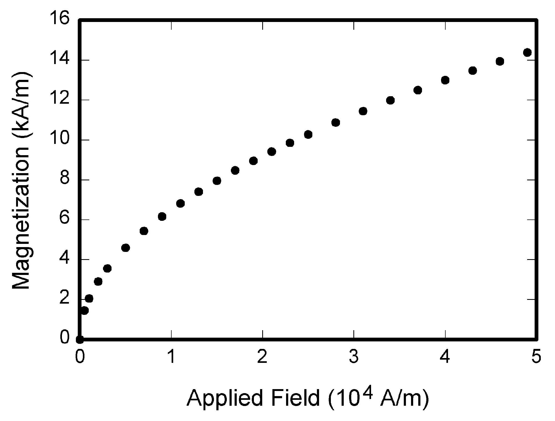
- Example of a figure caption. (figure caption)
The proper resolution of your figures will depend on the type of figure. Colour, and grayscale figures should be of at least 300 dpi. Line art, including tables should be of a minimum of 600 dpi.

Vector art
In order to preserve the figures’ integrity across multiple computer platforms, we accept files in the following formats: .EPS/.PDF/.PS. All fonts must be embedded, or text converted to outlines in order to achieve the best-quality results.

Colour space
All colour figures should be generated in RGB colour space (red/green/blue). Grayscale images should be submitted in Grayscale colour space.

Accepted fonts within figures
When preparing your graphics OPELRE suggests that you use of one of the following Open Type fonts: Times New Roman, Arial, and Symbol. If you are supplying EPS, PS, TIFF or PDF files all fonts must be embedded. Some fonts may only be native to your operating system; without the fonts embedded, parts of the graphic may be distorted or missing.
A safe option when finalizing your figures is to strip out the fonts before you save the files, creating “outline” type. This converts fonts to artwork what will appear uniformly on any screen.

Using labels within figures
1) Figure axis labels are often a source of confusion. Use words rather than symbols. As an example, write the quantity “Magnetization,” or “Magnetization M,” not just “M.” Put units in parentheses. Do not label axes only with units. As in Fig. 1, for example, write “Magnetization (A/m)” or “Magnetization (A m⁻¹),” not just “A/m.”
Figure labels should be legible, approximately 8 to 10-point type.
2) Subfigure labels in Multipart Figures and Tables
should be combined and labeled before final submission. Labels should appear centered below each subfigure in 8-point Times New Roman font in the format of (a) (b) (c).

Referencing a figure within your paper
When referencing your figures within your paper, use the abbreviation “Fig.” At the beginning of a sentence do not abbreviate and use “Figure”.

Positioning Figures
Large figures may span across both columns. Figure captions should be below the figures. Insert figures after they are cited in the text. Place figure captions below the figures; place table titles above the tables. Please do not include captions as part of the figures, or put them in “text boxes” linked to the figures. Also, do not place borders around the outside of your figures.

Tables
Please submit tables as editable text and not as images. Tables can be placed either next to the relevant text in the article. Number tables consecutively in accordance with their appearance in the text and place any table notes below the table body.
Table 1
Units for Magnetic Properties
Symbol | Quantity | Conversion from Gaussian and CGS EMU to SI ª
Φ | magnetic flux | 1 Mx → 10⁻⁸ Wb = 10⁻⁸ V·s
B | magnetic flux density, magnetic induction | 1 G → 10⁻⁴ T = 10⁻⁴ Wb/m²
H | magnetic field strength | 1 Oe → 10³/(4π) A/m
m | magnetic moment | 1 erg/G = 1 emu  → 10⁻³ A·m² = 10⁻³ J/T
M | magnetization | 1 erg/(G·cm³) = 1 emu/cm³  → 10³ A/m
4πM | magnetization | 1 G → 10³/(4π) A/m
σ | specific magnetization | 1 erg/(G·g) = 1 emu/g  → 1 A·m²/kg
j | magnetic dipole moment | 1 erg/G = 1 emu  → 4π × 10⁻¹⁰ Wb·m
J | magnetic polarization | 1 erg/(G·cm³) = 1 emu/cm³  → 4π × 10⁻⁴ T
μ_{r} | relative permeability | μ → μ_{r}
w, W | energy density | 1 erg/cm³ → 10⁻¹ J/m³
N, D | demagnetizing factor | 1 → 1/(4π)
Vertical lines are optional in tables. Statements that serve as captions for the entire table do not need footnote letters.
aGaussian units are the same as cg emu for magnetostatics; Mx = maxwell, G = gauss, Oe = oersted; Wb = weber, V = volt, s = second, T = tesla, m = meter, A = ampere, J = joule, kg = kilogram, H = henry.

Be sparing in the use of tables and ensure that the data presented in them do not duplicate results described elsewhere in the article. Please avoid using vertical rules and shading in table cells. Large tables may span across both columns. Table heads should appear above the tables. Insert tables after they are cited in the text. When referencing your tables within your paper, do not abbreviate “Table.”

Conclusions
The conclusions section is required. Although conclusions may review the main points of the paper, do not replicate the abstract as the conclusion. Conclusions might elaborate on the importance of the work or suggest applications and extensions.

Author statement
For research articles with several authors, a short paragraph specifying their individual contributions must be provided. The following statements should be used “research concept and design, X.X. and Y.Y.; collection and/or assembly of data, X.X.; data analysis and interpretation, X.X.; writing the article, X.X., Y.Y. and Z.Z.; critical revision of the article, X.X.; final approval of article, X.X. and Z.Z..”. Authorship must be limited to those who have contributed substantially to the work reported.

Acknowledgements
Put sponsor acknowledgements unnumbered at the end of the text and before References.

References and footnotes
Source references in the text of the article should be given in square brackets, e.g. [1], numbered consequentially in citation order and listed at the end of the manuscript. Please ensure that every reference cited in the text is also present in the reference list (and vice versa). Unpublished results and personal communications are not recommended in the reference list but may be mentioned in the text. If these references are included in the reference list, they should follow the standard reference style of the journal and should include a substitution of the publication date with either 'Unpublished results' or 'Personal communication'. Citation of a reference as 'in press' implies that the item has been accepted for publication.

Web references
As a minimum, the full URL should be given and the date when the reference was last accessed. Any further information, if known (DOI, author names, dates, reference to a source publication, etc.), should also be given.

References in a special issue
Please ensure that the words 'this issue' are added to any references in the list (and any citations in the text) to other articles in the same Special Issue.

Reference style
Text: as is mentioned above indicate references by number(s) in square brackets in line with the text. The actual authors can be referred to, but the reference number(s) must always be given.
List: Number the references (numbers in square brackets) in the list in the order in which they appear in the text. Using a reference manager program please choose Nature format for your references.
Reference to a journal publication should be in the following form: surname(s) and initial(s) of author(s), title of a paper, abbreviated journal name (italic) (e.g. https://cassi.cas.org/search.jsp), volume (bold), issue (only if needed), page numbers (inclusive) or identifier and year in brackets, DOI [1].
Reference to a book should be in the following form: surname(s) and initial(s) of author(s), title of a book (italic), pages and the publisher, year of edition (in brackets) [2].
Reference to a chapter in an edited book should be in the following form: surname(s) and initial(s) of author(s), title of a chapter, title of book (italic), surname(s) and initial(s) of editor(s) (in brackets), pages, the publisher, year of edition (in brackets) [3].
Reference to a website should be in the following form: surname(s) and initial(s) of author(s), title, source name, years, webpage address, and access data (in brackets) [4].
Reference to a journal publication in other language than English should be translated into English and at the end, the language of origin should be given [5].
Reference to a conference publication should be in form: surname(s) and initial(s) of author(s), title of a paper, conference name (italic), year [6].

Examples: (Normal.reference style)

- Pujolle-Robic, C. & Noirez, L. Observation of shear-induced nematic-isotropic transition in side-chain liquid crystal polymers. Nature 409, 167–171 (2001). https://doi.org/10.1038/35051537
- Goshtasby, A. A. 2-D and 3-D Image Registration. (John Wiley & Sons, Inc., 2004). https://doi.org/10.1002/0471724270
- Cuevas, E., Zaldívar, D. & Perez-Cisneros, M. Ellipse Detection on Images Inspired by the Collective Animal Behavior. in Applications of Evolutionary Computation in Image Processing and Pattern Recognition (eds. Zaldívar, D. & Perez-Cisneros, M.) 53–77 (Springer International Publishing, 2016). https://doi.org/10.1007/978-3-319-26462-2
- Andrew, E. Friend Or Foe: What The Shape Of Your Face Says About You. IFLScience (2015). Available at: https://www.iflscience.com/plants-and-animals/friend-or-foe-what-shape-your-face-says-about-you/. (Accessed: 30th October 2018).
- Yorozu, Y., Hirano, M., Oka, K. & Tagawa, Y. Electron spectroscopy studies on magneto-optical media and plastic substrate interface. IEEE Transl. J. Magn. 2, 40-41 (1987) [in Japanese].
- Franco−Anaya, R., Carr, A.J. & Schreiber, K U. Laboratory and in-situ measurements of structural rotations using fibre-optic gyroscopes. in 15th World Conference on Earthquake Engineering (15WCEE) (2012).

Footnotes
Number footnotes separately in superscripts. Place the actual footnote at the bottom of the column in which it was cited. Do not put footnotes in the reference list. Use letters for table footnotes.

Corresponding author at: corresponding author contact: eg. e-mail: author@university.edu.pl

